I. What are Invertebrates - animals that are not cordates (34 of 35 phyla)

II. Animal Biodiversity
A. 95% of animal species are invertebrates
1. 85% are arthropods
2. 75% of animal species are insects
3. 35% are beetles
B. Important evolutionary characters
1. symmetry (asymmetric, radial & bilateral)
2. tissue layers (diplo versus triploblastic)
3. true tissues (muscles and neural)
4. digestive tract (incomplete versus complete)
5. circulatory system (open, closed, absent)
6. Coelm (acoelomate, pseudocoelomate, coelomate)

III. Evolution of metazoan (all animals). SEE FIG. 32.11
- primitive animals were asymmetric and diploblastic with no true tissues (e.g. no muscle, nervous system, digestive system, etc).

IV. Phylum Porifera (sponges)
- Asymetric, diploblastic
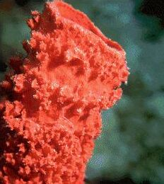
- No true organs
- Unique structures and cells
1. spicules – made of calcium carbonate or silica;
provide structural support
2. choanocytes (collar cells), amoebocytes
3. Diplobastic; 2 layers separated by gelatinous mesohyl

V. Evolution of Eumetazoans (animals with true tissues; all animals except sponges)
A. First eumetazoans have a rudimentary nervous and digestive system,
contractile tissues, and radial symmetry
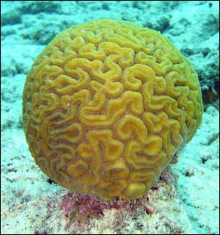
VI. Phylum Cnidarian (corals, jellyfish and hydras)
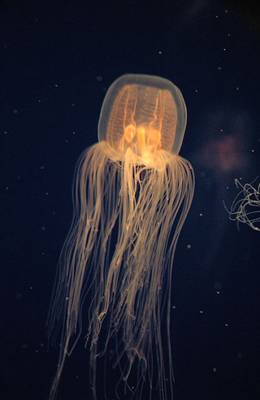
- Radially symmetric, diploblastic
- Two distinct body plans (medusa & polyp)
- Rudimentary Digestive tract / circulatory
system called gastrovascular cavity
- Nervous system – nerve net & ocili
- muscle-like structures
- Cnidocytes contain nematocysts

VI. Evolution of Bilateral symmetry and triploblastic tissues
- Three major bilateral animal groups
  - Deuterostomes - see previous lecture
  - Lophotrochozoa - it's complicated…don’t worry about it.
  - Ecdysozoa - animals that molt an exoskeleton (i.e. ecdysis)
- Evolution of triplobastic tissues allows evolution of coelom

LOPHOTROCHOZOA – Platyhelminthes, Rotifera, Mollusca and Annelida

VII. Phylum Platyhelminthes (flatworms; e.g. tapeworms, flukes, planeria)
A. Incomplete gut
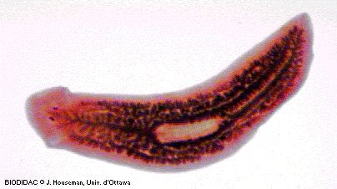
B. No circulatory system
C. Bilateral, triploblastic, acoelomates
D. Cephalization - evolutionary trend that
concentrates nervous tissue to one end
E. Can be free swimming or parasitic

VIII. Phylum Rotifera (wheel bearers)
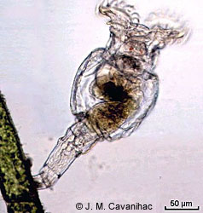
- Complete gut
- No circulatory system
- Corona - ciliated discs for feeding
- Parthenogenetic - asexual
1. some species produce non-
feeding males.

IX. Phylum Mullusca
A. Unique characters
1. 3 main parts: Foot, visceral mass, mantle (CaCO₃ shell)
2. radula – feeding apparatus
3. Range of cephalization and nervous systems
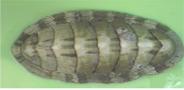
B. Classes
1. Polyplacophora (aka chitons)
a. 8 plates; live on intertidal rocks; scrape algae
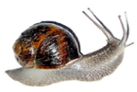
2. Gastropoda
a. Most have spiraled shells
(e.g. snails, conchs and whelks)
a. torsion - 180 degree twisting of visceral mass
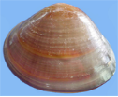
3. Bivalvia (clams, oysters, mussels and scallops)
a. hinged shell with adductor muscles
4. Cephalopoda (squid, octupi)
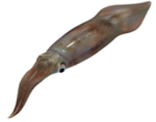
a. Means "head-foot”
b. no shell (except nautilus)
c. active hunters
d. learning and complex behavior

III. Phylum Annelida (segmented worms)
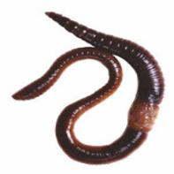
- Complete gut
- Closed circulatory
- Some cephalization
- Some possess parapodia - lateral feet

FIGURE 32.11

